**Issue tracking**

* Issues are associated with github repositories and allow you to keep track of "issues" such as bugs, future development plans, and so on. Major purposes are to:
  + organize who is addressing current problems with a project
  + plan changes (major and minor)
  + keep track of changes which will be made
  + in general, keep a permanent record of the development of a project so that it can be understood what changes were made, why, and by whom
* Issues normally should interact with pull requests -- specifically, the normal development process is:
  + an issue is raised to bring up a problem or plan development
  + the issue is used to make plans
  + someone begins development in a branch or fork and opens a pull request to master labeled "[WIP] Implement partial bond orders as discussed in issue #53" (for example), where [WIP] stands for "work in progress"
    - This allows people to see, comment on, and help with resolution of the issue
    - It keeps a record of exactly how the issue was dealt with
  + When the issue is resolved, "[WIP]" is removed from the title of the pull request, the issue is closed, and the pull request is merged, bringing the changes into master
* Find issues on the “Issues (#)” tab on the github website
  + 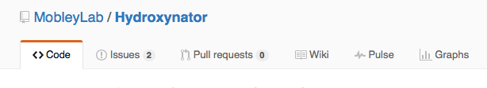
* Good Practice - try to keep issue limited to one problem *or* to several issues which are so closely related that they would best be dealt with by a single person in a single set of changes
* When creating an issue leave detailed comments about what is happening or what the problem that needs to be addressed is
  + Attach files or supporting materials to allow exact reproduction of the file
  + Code can be provided by using single quotes to indicate it is `code'; triple single quotes can be used to set off ```larger blocks of code''' that can span multiple lines (though you want your opening quotes on an empty line and your closing quotes on another empty line)
* You can assign a specific person to address an Issue:
  + 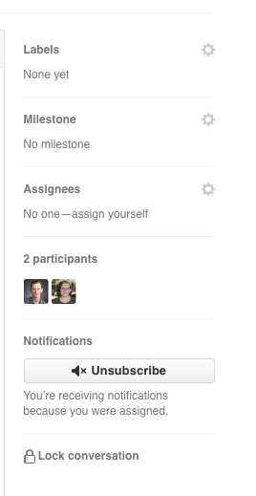Or chose “assign yourself” to assign yourself to be in charge of addressing the issue
* Good Practice - you should use pull requests to close issues. You can link a pull request to the issue by referring to it by number with (#number)
  +  this is an issue
  + If I was going to try to close it with a pull request I would put “This addresses issue #1” in the pull request so they are linked
  + Ideally, use names which describe what the pull request does, unlike the example above -- for example, "Ensure molecules retain the correct net charge" or something similar